Cross-Cultural Patterns in Meroitic Symbolism

Journey to the West: Death, Dying, and Transformation
Meroitic funerary texts use the phrase “ye imnt” (“go west”) to mean dying or entering the afterlife[1]. This matches a global pattern: in ancient Egypt the west (sunset) was the realm of the dead[2], and Meroitic “west” usage clearly echoes that. Other cultures likewise located the afterlife toward the west – for example, Mesopotamian Kur had its entrance “in the far west where the sun sets”[3], and the Greek Elysian Fields lay on the earth’s western edge beyond Oceanus[4]. By contrast, some cultures invert or vary the meaning: in Chinese myth the “West” is ruled by Xiwangmu, the immortal Queen Mother of the West, associated with eternal life and renewal rather than death[5]. Thus a “western journey” theme recurs worldwide, but with shifting nuance – journeying west can mean sunset/death (Egypt, Meroe, Maya), paradise (Greece), or immortal rebirth (China), illustrating a shared cosmological motif of cycles and thresholds.

Water and the Sacred: Offerings and Purity
Across many cultures water is both life and spirit. In Meroitic, ordinary water and sacred water are even lexically distinct – the word ato appears only in temple offerings, while common water uses a different term[6]. This distinction parallels other traditions: the Nile itself was personified as Hapy, whose annual inundation brought fertility, and Egyptian rituals centered on offerings to this god[7]. Hinduism likewise personifies rivers: the Ganges (Ganga) is a goddess who “descended to prepare the dead,” and bathing or offering in her waters is believed to purify soul and body[8]. More broadly, water rites (from baptism to libation) are ubiquitous – a “living water” of life-giving power appears in creation myths worldwide[9][8].
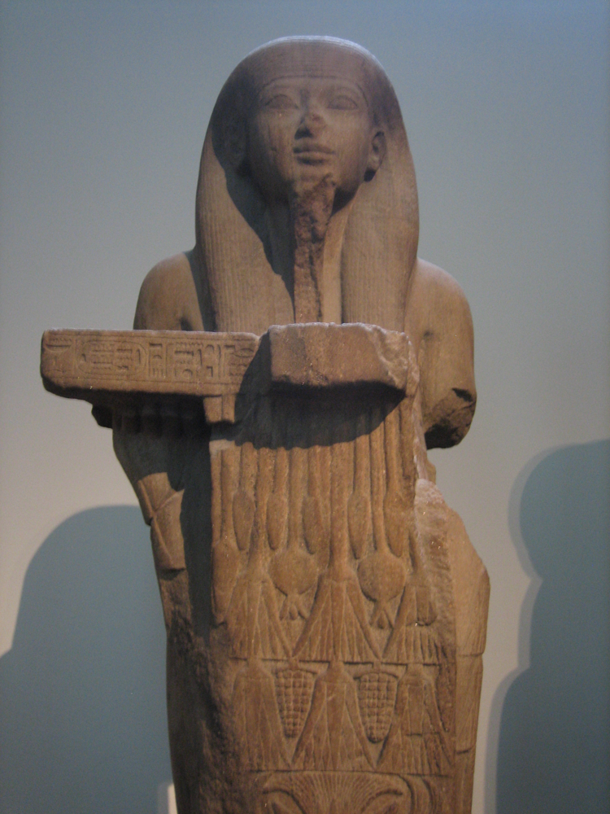
Fig: Hapy, the Nile-flood god, holds an offering-table (British Museum statue)[7]. Many cultures depict deities safeguarding rivers. The Nile god Hapy (shown above) embodies the river’s bounty and renewal[7], just as Kushite priests venerated “sacred water” in rituals. In each context, water symbolizes life and the boundary between worlds, whether cleansing souls in India or nourishing crops in Africa.

Kinship and Matrilineal Authority
Meroitic texts emphasize both father and mother: “se” names a father and “kde” a mother, often listing the king’s mother as prominently as the father[10]. The special title kandake (Candace) denoted the queen mother, an office of independent power[11]. This reflects a social system where royal succession ran through women. Such matrilineal succession is recorded in Kushite history – the king was crowned by his mother (the kandake) invoking Amun[12] – and echoes patterns in other African societies. For example, among the Akan of Ghana, the queen mother (Asantehemaa) is chosen from matrilineal lines and rules alongside the king, even overseeing succession and customs[13][14]. In other words, emphasizing kingship through the mother is a recurring motif: Greek Amazons, Celtic legends of warrior queens, or Southeast Asian queen mothers reflect similar themes of female lineage. Across these contexts, the social meaning shifts (from outright matriarchy to balanced gender roles), but the motif of royal identity anchored in the maternal line resonates widely.

Repetition, Names, and Ritual Language
Meroitic inscriptions often repeat sacred words as a kind of mantra. The kingdom’s name kdi (“Kush”) appears as “kdi kdi kdi” on royal decrees, functioning as an identity-invoking formula[15]. Researchers describe this as a “mantra” or consciousness-technology – writing was itself a ritual act to preserve identity[16][15]. Many traditions use similar linguistic devices: early Hindus uttered Vedic mantras thrice for emphasis, as even Vedanta texts explain that threefold repetition “instills assurance and respect” in ritual recitation[17]. Likewise, Christian liturgy famously repeats “Holy, holy, holy”, and Biblical psalms double or triple key phrases for sanctity. In Egyptian religion, a person’s name (ren) was magical – inscribing a name on a statue granted it existence, while erasing a name doomed the soul[18]. Thus repeating or preserving a name was universal magic-language: Meroitic scribes using kdi kdi kdi simply continue a global cognitive pattern where verbal formulas and names carry power[15][18].

Divine Kingship and Cosmic Order
Kushite rulers were portrayed not only as political leaders but as cosmic mediators. The king’s title mlo (ruler) is glossed as “consciousness ruler,” emphasizing his role in ordering reality[19]. In dedications the king invokes Amun-Ra and prays for Nile floods and good harvests, casting himself as guarantor of Maʿat (cosmic balance)[20]. This parallels the Egyptian pharaoh’s ideology: he was literally “Son of Ra” whose duty was to uphold Maʿat and keep chaos at bay. Globally, similar parallels appear: many ancient kings were seen as divine or semi-divine agents (e.g. the Maya “Holy Lords” or Chinese “Mandate of Heaven”). Icons reinforce this: the Walters plaque of King Tanyidamani shows the lion-god Apedemak with the king[21]. By reading the same inscription, we see Kush’s king making offerings to a war-god – much as, say, Assyrian kings set up stelae of themselves worshipping Ishtar. In each system the ruler’s earthly authority is tied to higher cosmic and religious roles, so that phrases and images of kingship carry layered meanings (political legitimacy, divine favor, societal well-being).
Fig: Votive plaque of King Tanyidamani, with lion-god Apedemak (walters.org)[21]. In Kush, as elsewhere, writing on monuments linked king and deity. This plaque’s Meroitic text names Tanyidamani and the god Apedemak[21], mirroring how Egyptian temples pair pharaohs and gods. The parallels show how ritual text reinforces divine kingship across cultures.

Environment, Cycles, and Climate Records
Kushite inscriptions contain environmental detail. Words for the Nile flood (ḥʿpy, “Hapy”) appear with qualifiers (“great flood”, “small flood”)[22], and a term for famine (ḥqr, “hunger”) occurs in late inscriptions tied to drought[23]. This essentially documents climate stress (~250–350 CE) and suggests literacy used for even mundane seasonal records. Analogously, many civilizations recorded environmental cycles: Egyptians invented nilometers and celebrated the inundation with hymns (the “Hymn to Hapy” rejoices that “when [Hapy] rises, the land is in joy”[7]). In Mesopotamia, royal inscriptions mention irrigation and grain harvest; Chinese dynastic annals often record droughts and floods; medieval Europeans noted weather in chronicles. In each, phrases for water and hunger map real events. The meaning shifts – in Kush it was prophetic doom, in others it might praise fertility or warn of famine – but it points to a universal awareness of nature’s cycles embedded in language.

Metals, Trade, and Material Wealth
Economic vocabulary reveals another pattern. Meroitic texts list gold (nbw) and iron (biꜣ)[24]. Ostraca records like “3 nbw” (3 gold ingots) appear in temple accounts, confirming Nubia’s legendary riches[24]. Indeed, Meroë was famed for metallurgy – English scholars nicknamed it “the Birmingham of Africa” due to its iron smelting[25]. Other cultures likewise boast specialty materials: Mesopotamia had lapis lazuli, Phoenicia purple dye; Ghana’s empires later did gold; Viking sagas mention steel. When a civilization produces specialized goods (gold from Nubia, iron in Meroe, silk in China), its script and records reflect that pride and its trade networks. Kushite parallels emerge: Egyptian hieroglyphs frequently name Nubian gold; Roman records cite Kushite gold and iron. The cross-cultural motif is that powerful states encode their wealth in writing – not just practical accounting, but as a statement of identity and continuity.

Symbols of Time and the Cosmos
Although explicit star-names in Meroitic are still tentative, the expectation of cosmic motifs is natural. The Meroitic term for “first time” in creation texts hints at a shared concept (Egyptians call primeval time Zep Tepi). While direct parallels in inscriptions are sparse, cosmic symbolism is almost universal. Egyptian tombs charted star paths for the king’s soul; Vedic rituals followed celestial schedules; Chinese and Maya calendars tied rulers to heavens. Even mythic language echoes: Kush’s water-and-mountain creation theme resembles global origin-stories (e.g. primeval waters and a rising earth in Sumerian and Norse myth). What does appear is that titles and formulas carry cosmic weight. For instance, when Kushite kings repeat kdi kdi kdi (“Kush Kush Kush”), it’s a ritual to preserve the kingdom’s essence – similar to how ancient religions repeated sacred names (in Hinduism, uttering a deity’s name thrice). These patterns suggest a universal cognitive architecture: humans everywhere invest cardinal directions, water, numbers and repetition with symbolic meaning, and use language to align their identity with cosmic order[2][17].
Sources: We compare insights from the Meroitic decipherment[15][22] with anthropological and historical records of ancient Egypt, Mesopotamia, Greece, China, India, and other traditions[2][3][4][5][7][8][12][13][18][17][25][16][21] to highlight recurring motifs and shifting meanings. Each citation points to evidence of these motifs across cultures, illustrating the deep symbolic continuity underlying diverse human worldviews.

[1] [6] [10] [11] [15] [19] [22] [23] Comprehensive Decipherment of the Meroitic Script_ A Multi-Disciplinary Analysis.docx
file://file_00000000874071f7b16dc6bb97471ecc
[2] Egyptian Religion | Westing
https://historyegypt.org/ideology/westing
[3] 5 Ancient Underworlds and What They Reveal About the Afterlife | TheCollector
https://www.thecollector.com/underworlds-different-cultures/
[4] Elysium - Wikipedia
https://en.wikipedia.org/wiki/Elysium
[5] Queen Mother of the West - Wikipedia
https://en.wikipedia.org/wiki/Queen_Mother_of_the_West
[7] Why ancient Egyptians needed the flooding of the Nile | National Geographic
https://www.nationalgeographic.com/history/article/nile-flooding-ancient-egypt
[8] [9] Sacred waters - Wikipedia
https://en.wikipedia.org/wiki/Sacred_waters
[12] THE KANDAKES OF KUSH: WARRIOR QUEENS OF ANCIENT AFRICA
https://www.thequeerclassicist.com/post/the-kandakes-of-kush-warrior-queens-of-ancient-africa
[13] [14] Asantehemaa - Wikipedia
https://en.wikipedia.org/wiki/Asantehemaa
[16] [20] [24] Refined Decipherment of the Meroitic Script.docx
file://file_00000000232c71f796ab75a6b97c74f2
[17] Repeated thrice: Significance and symbolism
https://www.wisdomlib.org/concept/repeated-thrice
[18] Ancient Egyptian conception of the soul - Wikipedia
https://en.wikipedia.org/wiki/Ancient_Egyptian_conception_of_the_soul
[21] Votive Plaque of King Tanyidamani, mid 2nd century BCE (Meroitic). Acquired by Henry Walters, 1923, 22.258 | The Walters Art Museum
https://art.thewalters.org/object/22.258/
[25] Meroë - Wikipedia
https://en.wikipedia.org/wiki/Mero%C3%AB

